Create a project in Azure Devops service in Azure . Example FastCarz

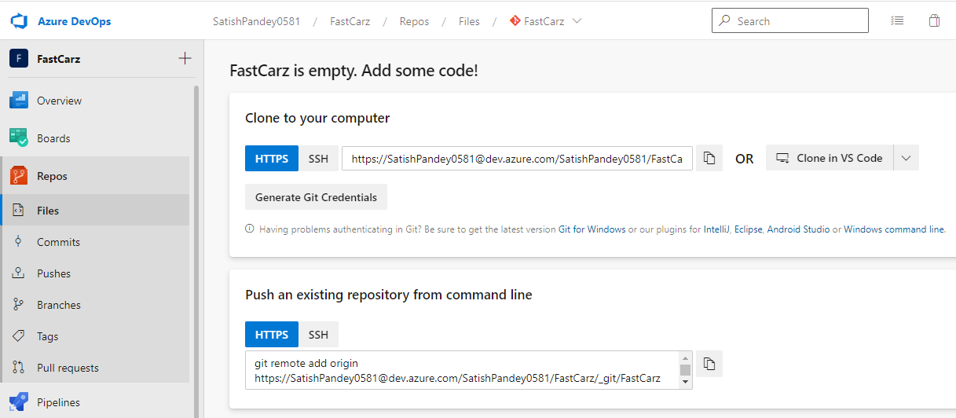

Link your project to the project which you created in Azure.List of supported scm

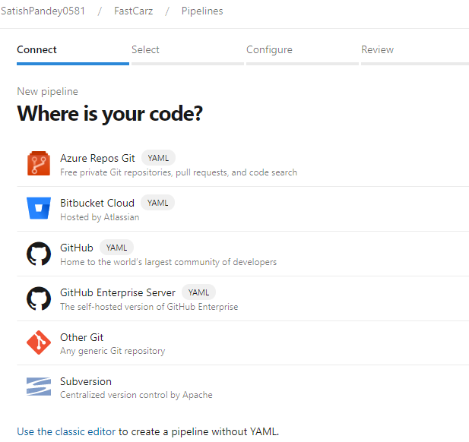

Once the project is configure and authorized to commit change,create a multi-stage pipeline with approval and gates.

Multi stage Pipeline yaml file in the repo for reference.

* It has three stages in the pipeline to deploy the build to dev,qa and prod environment.
* Put a approval at stage QA and Prod to manually promote the build from dev to QA ans PROD environment
* 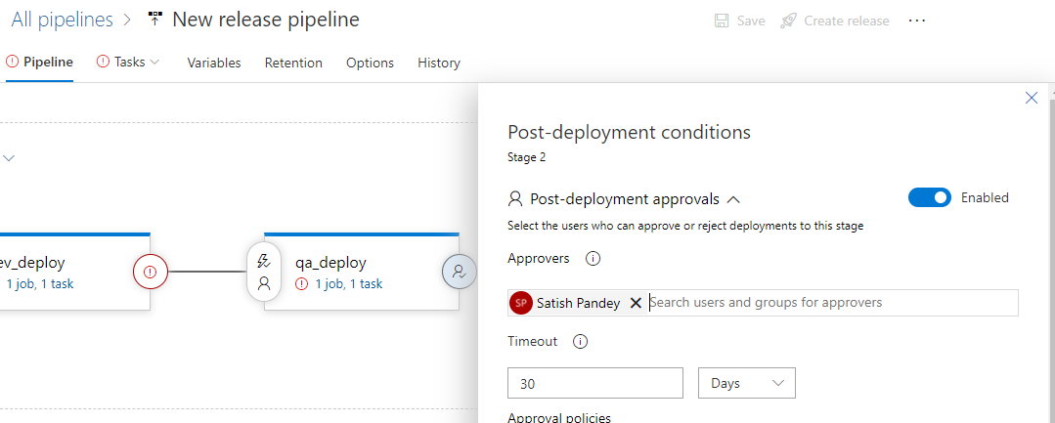
* Also put gate at dev label to check the test cas success rate ,if its 100% then pass and continu to nest stage else fail the pipeline. Example below to put gate at dev depoy for testcases
* 